**Practical No.06**

**Aim: Programs based on Two-Dimensional Array**

**1. C Program to Calculate Sum of all Elements in Array**

**Program:**

#include<stdio.h>

#include<conio.h>

void main()

{

int i, j, mat[10][10], row, col;

int sum = 0;

clrscr();

printf("\nEnter the number of Rows : ");

scanf("%d", &row);

printf("\nEnter the number of Columns : ");

scanf("%d", &col);

//Accept the Elements in Matrix

for (i = 0; i < row; i++)

{

for (j = 0; j < col; j++)

{

printf("\nEnter the Element mat[%d][%d] : ", i, j);

scanf("%d", &mat[i][j]);

}

}

//Addition of all Elements

for (i = 0; i < row; i++)

{

for (j = 0; j < col; j++)

{

sum = sum + mat[i][j];

}

}

//Print out the Result

printf("\nSum of All Elements in Matrix : %d", sum);

getch();

}

**Output:**

Enter the number of Rows : 2

Enter the number of Columns : 2

Enter the Element mat[0][0] : 1

Enter the Element mat[0][1] : 1

Enter the Element mat[1][0] : 1

Enter the Element mat[1][1] : 1

Sum of All Elements in Matrix : 4

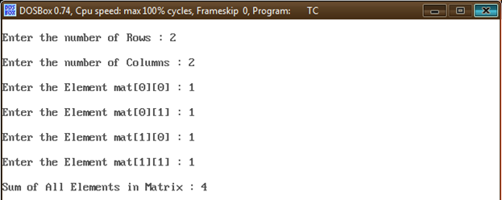

**2. C Program to Subtract Two Elements of Matrices**

**Program:**

#include <stdio.h>

#include <conio.h>

void main()

{

int m, n, c, d, first[10][10], second[10][10], difference[10][10];

clrscr();

printf("Enter the number of rows and columns of matrix\n");

scanf("%d%d", &m, &n);

printf("Enter the elements of first matrix\n");

for (c = 0; c < m; c++)

for (d = 0 ; d < n; d++)

scanf("%d", &first[c][d]);

printf("Enter the elements of second matrix\n");

for (c = 0; c < m; c++)

for (d = 0; d < n; d++)

scanf("%d", &second[c][d]);

for (c = 0; c < m; c++)

for (d = 0; d < n; d++)

difference[c][d] = first[c][d] - second[c][d];

printf("difference of entered matrices:-\n");

for (c = 0; c < m; c++)

{

for (d = 0; d < n; d++)

printf("%d\t",difference[c][d]);

printf("\n");

}

getch() ;

}

**Output:**

Enter the number of rows and columns of matrix

2 2

Enter the elements of first matrix

4 3

2 1

Enter the elements of second matrix

1 2

1 1

difference of entered matrices:-

3 1

1 0

